**Paul-David Jarvis - S5115232**

**Journeys**

Allows the user to enter a starting location, pick an end destination and enter a date. The results are returned as well with the starting location, end destination and date.

This feature works to an extent. The user can enter any starting destination and from a list of hard coded end destinations. The response that the user gets will display the TFL results but sometimes the project will crash if there is no valid journey.



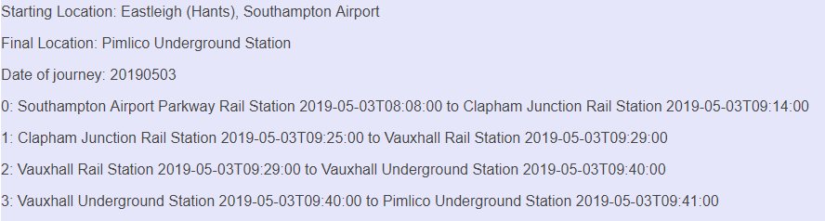

**Weather**

7 day forecast that shows the user what the weather will be in London.

Includes:

* 7 days
* Day temperature
* Night temperature
* Minimum temperature
* Maximum temperature
* Description of the weather
* An matching icon

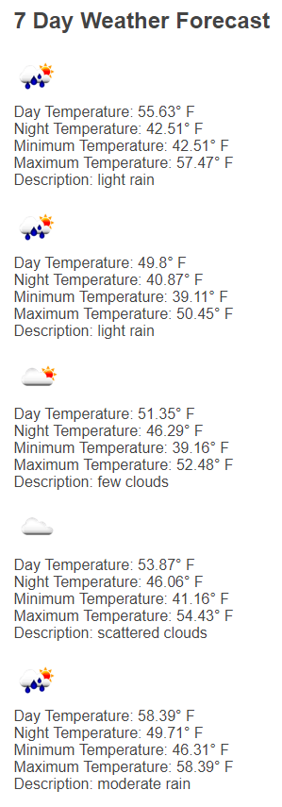

**News**

10 of the most recent news highlights released in the UK. I implemented it into my web application but it would be nice to only show the articles that relate strictly to London. I did manage to show the top headlines only relating to London, however the most there was two news headlines.



**Map**

A google map of the center of London.

Allows the user to:

* Navigate around London
* Zoom in and out
* Check what is close by
* Check around london in street view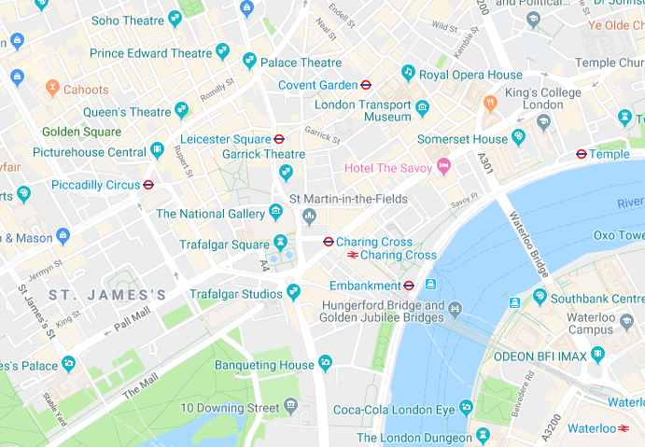

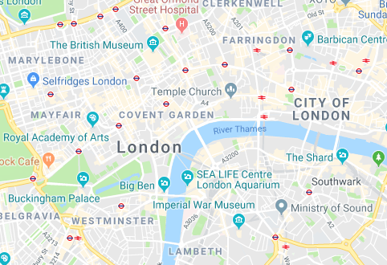

**Places**

I implemented a search function that allows the user to search for results in London by typing in a query such as ‘bar’ or ‘school’. The results return the location’s name, address and rating. There is sometimes errors when there are no locations for whatever the user inputted.

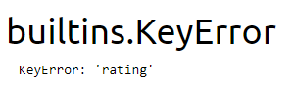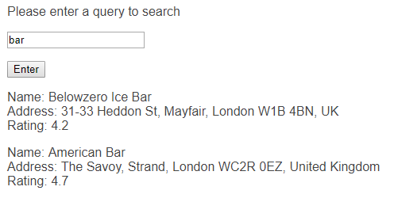

**Directions**

I attempted to implement a feature that will allow the user to input a searching result such as Bournemouth and a destination such as London and a mode of transport such as driving, this would have returned the user results that include the steps they would’ve to take to arrive at this location. However, I couldn’t fully implement it due to issues that I didn’t know how to resolve.